Curriculum Vitae
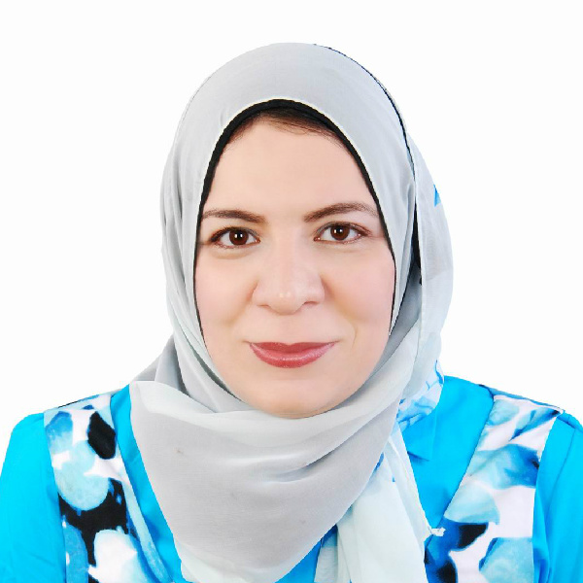
Name: Eman bahaa eldeeneen fawzi kamaleldeen
Date of Birth: 20/2/1983.
Place of Birth: Assiut.
Residence: Assiut, Egypt.
Nationality: Egyptian.
Tel: +01002944977
E-Mail: emanemmy83@yahoo.com
Marital Status: Married with3 kids

Academic Qualifications:
- Membership of the Royal College of Pediatrics and Child Health (MRCPCH), part 1 and 2 september, 2013.
- Master Degree in Pediatrics (MSc) with a general grade of very good in June, 2010 from the Faculty of medicine, Assiut University.
- Bachelor of Medicine and Surgery (M.B.B.CH.) with a general grade of Excellent with honor (ranked the seventh best on class), Faculty of Medicine, Assiut University, September, 2005.

Previous Jobs:
- Assistant Lecturer and specialist in endocrinology department Assiut University Children Hospital, Faculty of medicine, Assuit University from 27/06/2010 till now.
- Demonstrator in Department of Pediatrics, Faculty of medicine, Assuit University from 01/03/2010 till 27/06/2010.
- Resident physician in the Assiut University Children Hospital from 01/03/2007 till 01/03/2010.
- House officer at Assiut University Hospitals from 01/03/2006 till 28/2/2007 (2 months in each; pediatrics, obstetric and gynecology, ER, internal medicine, surgery and anasthesia).

- Assiut University Hospital (http://www.aun.edu.eg/hospitals/english) serves as the Southern Egypt largest academic clinical health complex that combines patient care, medical education and biomedical research besides the community outreach health services. The main hospital is serving a population of more than 20 million and has 2000 beds. Assiut University Children Hospital was added to the main hospital 7 years ago and it is the largest hospital in Upper Egypt and its capacity about 1900 beds and the capacity of Assiut University Children Hospital about 400 beds.

- Faculty of medicine, Assiut University is one of the largest and the third oldest medical faculty in Egypt. It has been accredited from the National Authority for Accreditation and Qualification in July 2012.

Practical Experiences:
- As resident and specialist physician at Assiut University Children hospital, I worked at the following pediatric units:
1- Emergency Unit:
Dealing with cases of pediatric emergency including:
- Acute neurological conditions such as seizures, coma, acute paralysis, etc..
- Acute respiratory presentations such as respiratory distress, respiratory failure, foreign body inhalation,etc..
- Poisoning and envenomations , drowning and near drowning and electric shock
- Acute hematological conditions such as bleeding or acute pallor, etc..

2- Neonatal intensive Care Unit (NICU):
The neonatology unit (with a capacity of about 50 incubators) includes an intensive care unit, an intermediate care unit, isolation ward in addition to the ordinary ward.

We deal with the following cases:
- preterm babies and their complications such as feeding problems, respiratory problems, sepsis, circulatory disturbances, neurological and GIT complications, neonatal jaundice, and postoperative care of cases like TOF, intestinal obstruction, and others.
I have experienced the following neonatal procedures:
- Umbilical artery catheterization, umbilical vein catheterization.
- Exchange transfusion for cases of severe neonatal jaundice.
- Endotracheal intubation and connection to mechanical ventilation and CPAP machines and surfactant administration.
- I got also the experience of how to read X-ray films and interpret blood gases.

3- Pediatric Intensive and Intermediate Care Unit (PICU):
The PICU capacity is 12 beds and capacity of intermediate care is about 22 beds. I have dealt with the following cases:
- Respiratory emergencies; as croup, foreign body aspiration, severe asthma, severe pneumonia with RD, bronchiolitis, pneumothorax and type II respiratory failure.
- Cardiac emergencies; as acute heart failure, cardiogenic shock, acute infective endocarditis, postoperative intensive care support and pulmonary edema.
- Neurological emergencies; as refractory status epilepticus, deep coma, Guillian Barree syndrome and raised intracranial pressure.
- Other cases of critically ill child; as refractory shock, septicemia, diabetic ketoacidosis, near-drowning, electric shock and envenomation.

4- Nephrology and Artificial Kidney Unit:
Its capacity is about 22 beds with 12 machines for haemodialysis.
I dealt with the following cases:
Nephrotic Syndrome, nephritis, hematuria, UTI, renal tubular acidosis ,obstructive uropathy and renal failure (acute and chronic) and other renal diseases
I was trained to perform peritoneal dialysis and to manage patients during haemodialysis settings.

5- Hematology Unit and Thalassemia center:
Its capacity is 20 beds and thalassemia center 8 beds.
I dealt with the following cases:
- Different type of anaemias including sickle cell anemia, thalassemia, spherocytosis, G6PD, acute hemolytic crisis and others
- Cases of bleeding tendency such as hemophilia, platelet disorders and others.
- We also manage cases with Gaucher’s disease and niemann pick disease.

6- Cardiology Unit:
Its capacity is 16 beds. dealt with the following cases:
- Congenital heart diseases
- Rheumatic heart diseases
- Cardiomyopathies
- Arrythmias
- Kawasaki disease
- I can interpretate ECG and manage acute cardiac presentations including hypercyanotic spells, acute heart failure, endocarditis, myocarditis and others.

7- Gastroenterology and Hepatology Unit:
Its capacity is 6 beds .I dealt with the following cases:
- Congenital G.I.T anomalies such as congenital hypertrophic pyloric stenosis, hurschsprung disease, malrotation and others
- Hepatitis, cholestasis, liver cirrhosis and portal hypertension
- Chronic diarrhea and malabsorption

8-Rehydration and Malnutrition Unit:
Its capacity is 45 beds. I dealt with the following cases:
- Acute gastroenteritis with its complications including shock, electrolyte imbalance, DIC, intussusception, paralytic ileus, tetany, pre renal failure and others.
- Cases of malnutrition such as rickets, marasmus and Kwashiorkor.

9- General ward:
Its capacity is 26 beds. I dealt with many cases such as:
Pyrexia of unknown origin, rheumatological diseases, immunological disorders, metabolic diseases and others.

10- Pulmonogy and T.B. unit:
Its capacity is 16 beds. I have dealt with the following cases:
Respiratory diseases as pneumonia , bronchiolitis , bronchial asthma ,pleural effusion ,suppurative lung diseases ,tuberculosis (pulmonary & extrapulmonary ) ,post B.C.G. vaccination lymphadenitis ,recurrent chest infection ,persistent respiratory noises and interstitial lung diseases .
I m also well trained in the interpretation of chest X ray, C.T. chest and tuberculin test .

11- Metabolic and genetic diseases unit:
Its capacity is 2 beds. I have seen and managed patient with chromosomal disorders as down syndrome, Edward syndrome, Pateau syndrome and others
I have also dealt with many metabolic diseases as phenylketonuria, galactosaemia, tyrosineamia and others.

12- Outpatient Clinics:
In the outpatient clinics, I have worked in different clinics as general clinic, hematology, nephrology, cardiology, TB, pulmonology, endocrinal, hepatic and gastroeneterology clinics and clinic for metabolic and genetic diseases.

- As assistant lecturer at Assiut University Children hospital, I worked in endocrinology unit:

Its capacity is 8 beds. I have dealt with the follow cases:
Diabetes mellitus, short stature, thyroid problems , ambigious genetalia, obesity , adrenal disorders and others .
My doctorae thesis about effect of angiotensin antagonists on microvascular complications in children and adolescence with type 1 diabetes mellitus.

Scientific Activities:

Master (MSc) in Pediatrics thesis: neurological emergencies in pediatric ICU
Doctoral degree (MD) in Pediatrics thesis: about effect of angiotensin antagonists on microvascular complications in children and adolescence with type 1 diabetes mellitus

Weekly Scientific Activities:
In the dept .of pediatrics
- Medical seminars every Tuesday.
- Case presentation and conferences every Sunday and Wednesday.
- Seminar for continuous improvement of qualification and accreditation every Monday.
- Daily grand round from 8 to 9 am attending lecturers and presentation of new cases that have been admitted to the hospital.
- Monthly lecture presented by neuropediatric unit staff.

Conferences and Workshops:
- Pediatric fundamental critical care support course (PFCCS) July 2012 (support provider with a valid card).
- Attendance and participation in the activities of Pediatric Respiratory Emergencies workshop and Advanced Life Support course of Pediatric Department, Faculty of Medicine – Assuit University (January, 2012).
- The ^{5th} Scientific conference of Pediatric Department Faculty of Medicine –Assuit University (November, 2006).

Other activities:
- Participating in 2 medical campaigns to poor villages in Egypt (2009, 2010)
- University Staff Developing programs:
- Financial and legal aspects in the university (May, 2009).
- Effective communication (May, 2009).
- E-Learning (May, 2009).
- Scientific Publication (May, 2009)
- Quality Standers in Teaching (May, 2009).
- Strategic planning (May, 2009)
- Research Team Management (May, 2013).
- Student evaluation (May, 2010)
- Quality standards in teaching (May, 2010)
- Research ethics (January, 2013)
- Use of technology in teaching (January, 2013)
- Effective presentation (June, 2010)
- Qualification for effective teaching course (March, 2010)

Skills
- Language: - Native Arabic. - English.
.
- English language course and exam level 1 from Assiut university English language centre program (score 96/100) (June, 2014).

All documents and certificates are available upon request.

